# The Grid Problem

## Definition

Given a collection of 2D points, create an algorithm that classifies each point into rows and columns.

## Background

If one plots the collection of points described above in a piece of paper with traditional x and y axes, it would look something like this:

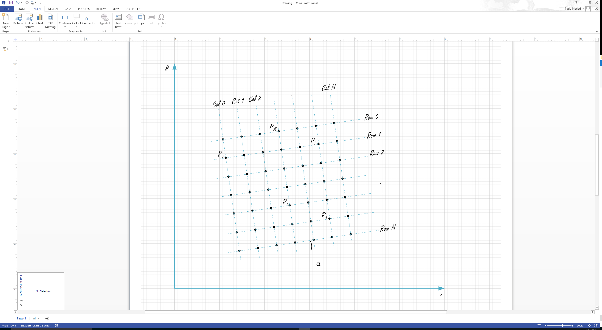

From the illustration above, we extract a few observations:

* Points form a grid in 2D space.
* Input points are in no particular order.
* The grid is square – there are the same number of rows as columns.
* The grid is fully populated – there are no missing points.
* The distance between two neighboring points in the same row or column is constant.
* Columns and Rows may or may not be aligned with the x and y axes.
* The number of columns and rows are arbitrary.

## Input and Output

Create a program that reads a text file containing a set of tuples representing 2D points and outputs a report to the standard console as described below. The input file name shall be given as an argument for the command line program.

For a bonus point, calculate α, the angle between any row and the x axis.

Here is an example of an input file containing 9 2D points:

14.0,10.0<CR><LF>

10.0,10.0<CR><LF>

12.0,10.0<CR><LF>

10.0,12.0<CR><LF>

10.0,14.0<CR><LF>

12.0,12.0<CR><LF>

14.0,12.0<CR><LF>

14.0,14.0<CR><LF>

12.0,14.0<CR><LF>

And here is a sample program output (standard console) using the points above. Rows should be listed first in ascending order, then columns. For each row printed, points shall be listed in ascending order of column. For each column printed, points shall be listed in descending row order.

Row 0: 10.0,14.0 – 12.0,14.0 – 14.0,14.0

Row 1: 10.0,12.0 – 12.0,12.0 – 14.0,12.0

Row 2: 10.0,10.0 – 12.0,10.0 – 14.0,10.0

Col 0: 10.0,14.0 – 10.0,12.0 – 10.0,10.0

Col 1: 12.0,14.0 – 12.0,12.0 – 12.0,10.0

Col 2: 14.0,14.0 – 14.0,12.0 – 14.0,10.0

Alpha=0.0 degrees

You will be evaluated in program correctness, OOP design and quality of code in general. Please state any assumptions adopted in the solution.